

**Parivartan Apigee DevOps**

Version 0.1

Prepared By

**Wipro Limited**



**Document Control**

|  |  |
| --- | --- |
| Document Name | Parivartan_Apigee_DevOps_Approach |
| Current Version | 0.1 |
| Issue Date | 02-Sep-2020 |

**Document Revision History**

|  |  |  |  |
| --- | --- | --- | --- |
| **Version #** | **Date Updated** | **Revision Author** | **Brief Description of Changes** |
| 0.1 | 02-Sept-20 | Raja Sekhar | Draft version |
|  |  |  |  |

Table of Contents

1. Introduction 4

1.1 Purpose 4

1.2 Prerequisites 4

1.3 API Bundle 4

1.4 Development Environment 4

1.4.1. Create a Folder Structure 4

1.4.2 Create and Configure pom files 5

# Introduction

## Purpose

The purpose of this document is to provide DevOps CICD approach for Apigee api-proxy in Parivartan project.

## Prerequisites

You will need the following to run the deployment

1. Apigee Edge developer account
2. Java SDK >= 8
3. Maven 3.x

## API Bundle

Apigee bundle is a zipped file system composed of configuration, scripts and code. The file system when extracted is composed of the following structure.

|-apiproxy/

|-proxies

|-resources

|-policies

|-targets

## Development Environment

It describes the local environment setup for development

# 1.4.1. Create a Folder Structure

|-name-of-root (company name)

|-archive/

|-docs

|-binaries/

|-build-artifacts/

|-src/

|-analytics

|-gateway/ ***

|-name-of-api-proxy/ (Garage name)

|-apiproxy/

|-proxies

|-resources/

|-py

|-policies

|-targets

|-java

|-portal

|-test

File/Folder Purpose:

{ApiName}.xml: - A file that contains descriptors for the content

policies/: - A folder that contains all xml policy files

proxies/: - A folder that contains information about your proxy configurations (inbound from UI to Apigee)

targets/: - A folder that contains information about target configurations (outbound from Apigee to Backend microservice)

resources: - A folder that contains any scripts (java, javascript in jsc, python in py, node)

# 1.4.2 Create and Configure pom files

Root folder has the pom file, it bundles with the project dependencies and Apigee proxies inside the nseindia folder, which has three sub folders that is gateway, config and sharedflows.

Gateway contains apiproxy folder, which has the microservice details.

Config contains the complete Apigee organization and environment configuration details

Sharedflows which is contains the policies bundle, which can used by multiple apiproxies.

* + - 1. Deployment

Apiproxy: - Using Maven command to deploy the apiproxies into Apigee environment

$ cd {root-folder}/nseindia/gateway/{api-proxy-folder-garage}

Ex: - $ cd nse-apigee/nseidia/gateway/global

$ nse-apigee/nseindia/gateway/global > mvn install -P{environment} -Dusername={email Id} -Dpassword={password} -Dorg={organization}

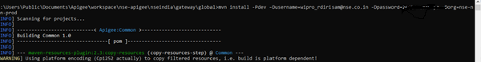

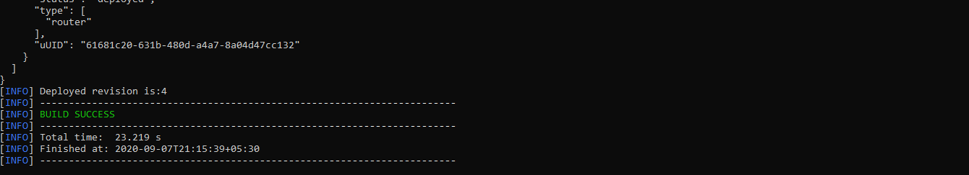

Config: - Same as Apiproxy deployment, here also we use maven command to deploy apigee config. It classified into three ways that is environment config, organization config, and api config. The configuration hold by edge.json file and it placed inside the config folder and to deploy the apigee config, please follow below steps,

$ cd {root-folder}/nseindia/config/

Ex: - cd nse-apigee/nseindia/config

$ nse-apigee/nseindia/config > mvn install -P{profile} -Dusername={email Id} -Dpassword={password} -Dorg={organization} -Dapigee.config.options={option} -Dapigee.config.dir={config directory} -Dauthtype={type of oauth} -Dmfatoken={mfa token}

$ nse-apigee/nseindia/config > mvn install -Pdev -Dusername=wipro_rdirisam@nse.co.in -Dpassword=XXXXX -Dorg=nse-non-prod -Dapigee.config.options=create -Dapigee.config.dir=resources/edge -Dauthtype=oauth -Dmfatoken=106225

Config.options: -

none - No action (default)

clean – This will delete the last deployed revision in an environment

create - Create when not found. Pre-existing config is NOT updated even if it is different.

update - Update when found; create when not found, updates individual entries for kvms. Refreshes all config to reflect edge.json.

delete - Delete all config listed in edge.json.

sync - Delete and recreate.

-Dapigee.config.file=<path-to-config>

path containing the configuration.

-Dapigee.config.dir=<dir>

directory containing multi-file format config files.

Sharedflows: - use below command to deploy the shared flows

$cd {root-folder}/nseindia/sharedflows/

Ex: - nse-india/nseindia/sharedflows

$ nse-india/nseindia/shareflows > mvn install -Pdev -Dusername=wipro_rdirisam@nse.co.in -Dpassword=XXXXX -Dorg=nse-non-prod